II. Demo

2.1. SYN Flood Attack

2.1.1. Experiment Description
Prepare the environment: two PCs (PC0 and PC1) on the same LAN.
- PC0: a Kali Linux virtual machine (VM) used as the attacker.
- PC1: an Ubuntu virtual machine (VM) used as the target/victim for attack testing.
Scenario:
- Objective: Exhaust the server’s resources by creating many half-open connections so legitimate users cannot connect.
- Attack method: The attacker sends many TCP packets with only the SYN flag set. The server replies with SYN/ACK, but the attacker never sends the final ACK, leaving connections half-open in the backlog.
- Result: Server's connection queue fills and legitimate users are denied service.
Tools | Command | Notes
Hping3 | sudo hping3 -S IP -p 9091 -d 230 --flood --rand-source | -S specifies setting the SYN flag  --flood sets the mode to send packets as fast as possible, without caring about replies  --rand-source generates a random source address  -p is the target port  -d specifies the data size
Iptables | sudo iptables -N syn_flood  sudo iptables -A INPUT -i ens33 -p tcp --syn -j syn_flood  sudo iptables -A syn_flood -m limit --limit 1/s --limit-burst 10 -j LOG --log-prefix "SYN flood: "  sudo iptables -A syn_flood -m limit --limit 1/s --limit-burst 10 -j RETURN  sudo iptables -A syn_flood -j DROP | - Creates a custom rule group (chain) named syn_flood  - Redirects ALL incoming TCP SYN packets (new connection requests) to the syn_flood chain for processing.  - This is the most important rule. It allows a limited number of packets (e.g., 1 per second, with a burst of 10) to pass through.  - RETURN means "accept" and allows the legitimate connection.  - Logs the excessive packets to the system log for monitoring.  - Any SYN packet that exceeds the limit set in step 3 is dropped. This is the action that blocks the attack.
glances | sudo glances | monitor CPU, Load Average, Memory, Network Interfaces, Disk I/O, Processes, and File System space utilization.
wireshark | sudo wireshark & | Capture the attacking packets
Table 2. Tools of SYN Flood Attack

2.1.2. Attack Experiment
Step 1: Use command: sudo hping3 -S IP -p 9091 -d 230 --flood --rand-source
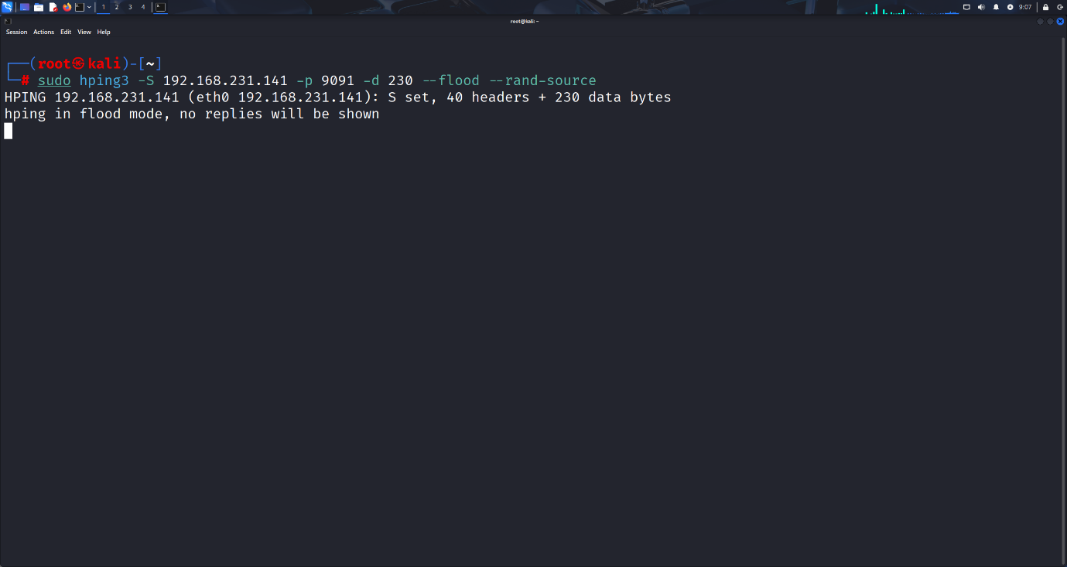
Figure 1. Attacker by using hping3
Result: Watch the result that many connections are in a state of waiting for a reply, CPU usage increases, Usage of other resources such as network, disk also increases.
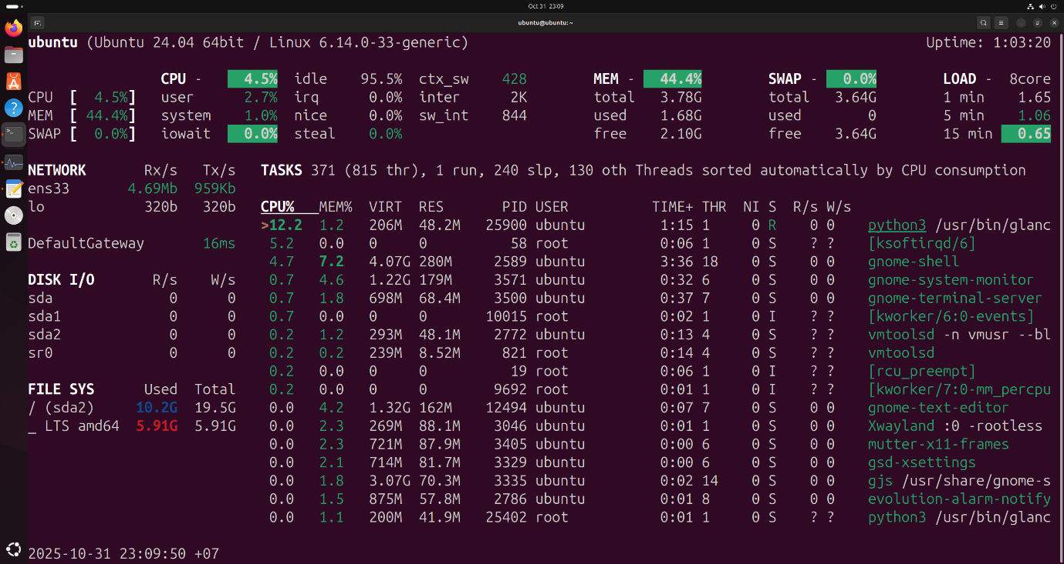
Figure 2. Using glances to check resources
Checking with Wireshark shows that a large number of TCP packets carrying the SYN flag are sent, and after a while, RST flags are sent back from the victim machine to reset the connection. Checking the packet payloads, as per the default design of hping3, the packets themselves will contain the characters XXXXXXXXXX; in practice, the packets will be randomized or carry repeated characters.
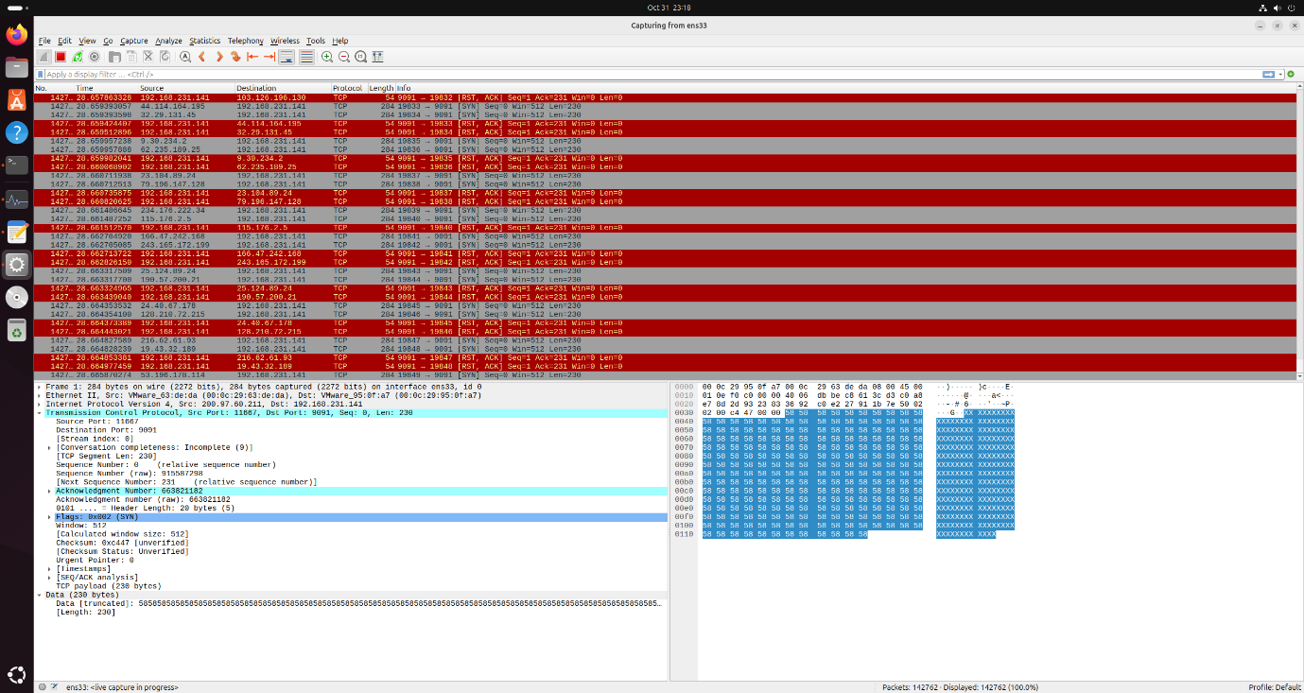
Figure 3. Using Wireshark to check packets

2.1.3. Defense Experiment
Step 1: Use all command:
sudo iptables -N syn_flood
sudo iptables -A INPUT -i ens33 -p tcp --syn -j syn_flood
sudo iptables -A syn_flood -m limit --limit 1/s --limit-burst 10 -j LOG --log-prefix "SYN flood: "
sudo iptables -A syn_flood -m limit --limit 1/s --limit-burst 10 -j RETURN
sudo iptables -A syn_flood -j DROP
Result: Checking shows that the victim's machine is operating normally without a sudden spike in CPU as when it was attacked.
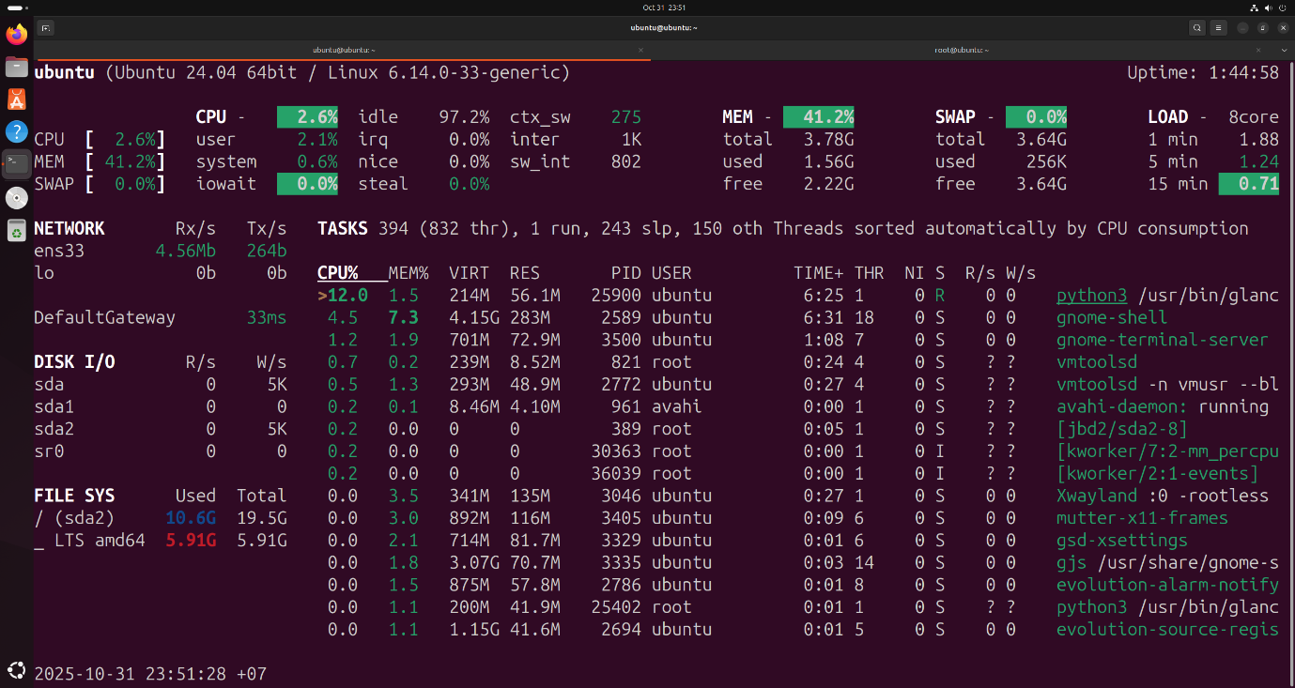
Figure 4. Using glances to check resources
On Wireshark, there are no longer Rst flags being sent back to the attacking machine and connections are no longer being dropped. Proceeding to check the connections again, there are no longer any connections being held.
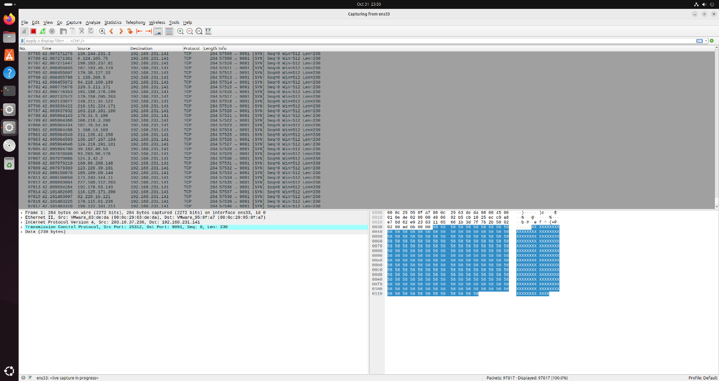
Figure 5. Using Wireshark to check packets
We can also check /var/log/kern/log that iptables prevent SYN Flood.

Figure 6. Check logs

2.2. HTTP Get Attack

2.2.1. Experiment Description
Prepare the environment: two PCs (PC0 and PC1) on the same LAN.
- PC0: Kali Linux virtual machine used for attacking..
- PC1: Ubuntu virtual machine with the apache2 service turned on to test the attack.
Scenario:
- Objective: To exhaust the server's connection pool (maximum concurrent connections), making the server unable to accept connections from legitimate users.
- Attack method: The attacker opens many HTTP connections to the server. Instead of sending a complete request, the attacker intentionally keeps the requests "incomplete" and maintains these "hanging" connections for as long as possible.
- Result: Since all of the server's available connection "slots" are occupied by the attacker's hanging connections, the server exceeds its connection limit. Consequently, any legitimate user attempting to connect afterward will be denied service.
Tool | Command | Notes
slowhttptest | sudo slowhttptest -c 65539 -H -g -o ./result -i 10 -r 200 -t POST -u <URL> -x 24 -p 2 | -H is to use slow header mode (send header slowly)  -g to generate statistics, -o to save statistics to a file  -i is the interval between data packets sent  -r is the number of connections to open per second  -t is the method to use  -u is the URL to exploit  -p is the HTTP response timeout to wait for from the probe connection
htop | sudo htop | monitor system performance, analyze resource usage, and manage processes efficiently through a clear, interactive, and real-time interface.
Table 3. Tools of HTTP Get Attack

2.2.2. Attack Experiment
Step 1: Use command: slowhttptest -c 65539 -H -g -o ./result -i 10 -r 200 -t POST -u <URL> -x 24 -p 2
Result: After the attack, it is observed that connecting to the service is no longer possible. Pinging the victim machine is completely possible, which proves that the service (not the machine itself) has been denied. The server is slow, causing the web page to be inaccessible.

Figure 7. Apache2 server
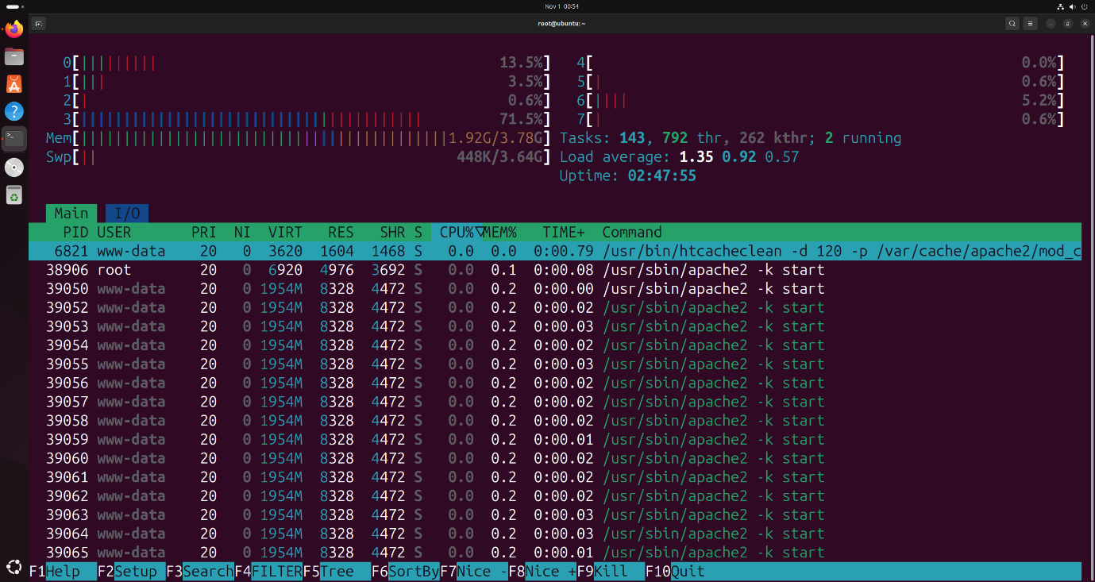
Figure 8. Using htop to check resources
But network services on the machine are still normal. Like the http type above, the number of processes related to the server also increases suddenly.
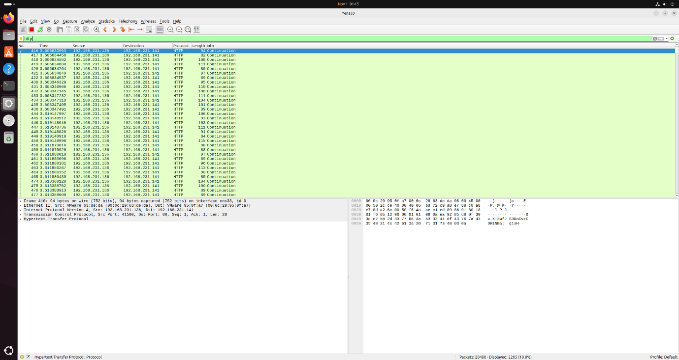
Figure 9. Using wireshark to check packets

2.2.3. Defense Experiment
Step 1: Install the library: sudo apt-get -y install libapache2-mod-evasive And re-configure the file according to usage needs: Or you can use the library specialized for slowloris: sudo apt-get -y install libapache2-mod-qos and re-configure the file /etc/apache2/mods-available/qos.conf
Step 2: Execute the following commands:
sudo mkdir -p /var/log/apache2/evasive
sudo chown -R www-data:root /var/log/apache2/evasive
Step 3: Re-configure the file /etc/apache2/mods-available/mod-evasive.load according to usage needs
DOSHashTableSize 2048
DOSPageCount 20 # maximum number of requests for the same page
DOSSiteCount 300 # total number of requests for any object by the same client
DOSPageInterval 1.0 # interval for the page count threshold
DOSSiteInterval 1.0 # interval for the site count threshold
DOSBlockingPeriod 20.0 # time that a client IP will be blocked for
DOSLogDir "/var/log/apache2/evasive"
DOSEmailNotify admin@domain.com
Result: After performing the attack again, it will be seen that the attacking machine will be blocked and cannot connect to the apache web service. In addition, pinging the victim machine will still be performed normally, proving that the service has been blocked.

Figure 10. Prevent Ddos

Using wireshark, it will be seen that the connection to the web service will be dropped.
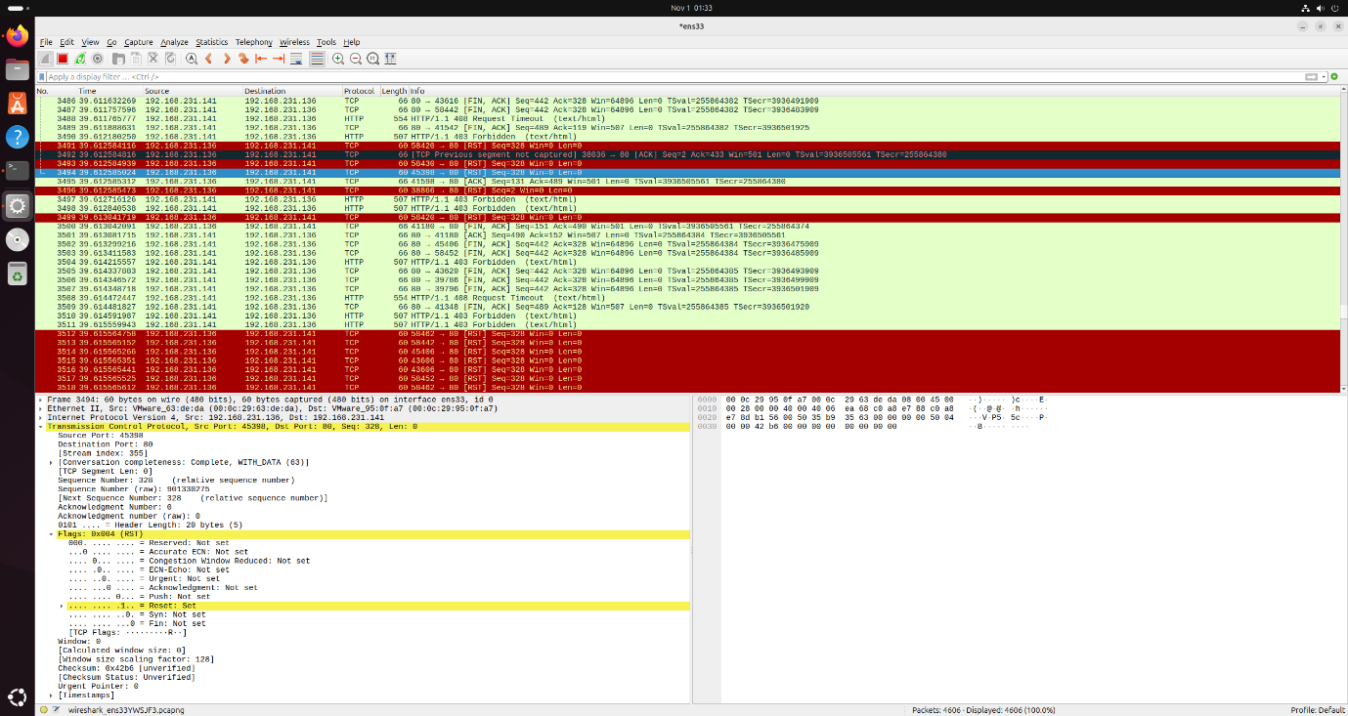
Figure 11. Use wireshark to check packets

